«Conversion matrix for the Payment Card Transactions»

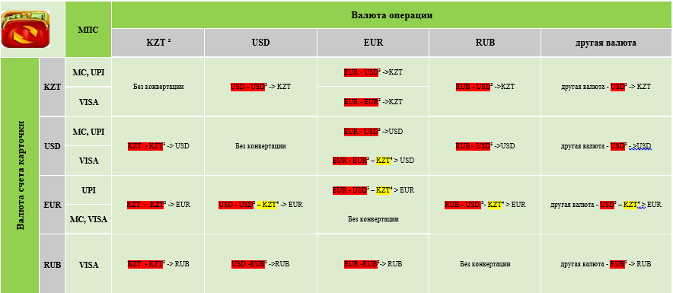

² Settlements in the territory of the Republic of Kazakhstan are made only in national currency - tenge
³ Currency which is used by the international payment system (hereinafter the IPS) for settlements with the Bank
⁴ The issuer shall make conversion at rates established by the Bank on the date of debiting money from the Payment Card Account through the local currency of the Republic of Kazakhstan - tenge, since the Bank does not use the cross rate between currencies EUR – USD/ USD – EUR

